# **INFO-6028 Graphics 1 Midterm exam, 2023**

Friday, October 27th, 2023

Instructor: Michael Feeney

## The exam format:

* You may use any resources you feel are necessary to complete the exam, but you are to answer the questions **on your own**. I will be looking for plagiarism (i.e. copying) very carefully. There is *no possible way* that the specific code to answer these questions, or the output to the screen, would be very similar to the look of another student’s code. Remember, this is a test and there are very clear policies about cheating on tests.   
  + <http://www.fanshawec.ca/admissions/registrars-office/policies/cheating-policy>
  + <http://www.fanshawec.ca/sites/default/files/assets/Ombuds/cheating_flowchart.pdf>
* It is an “open book” exam. You have access to anything you book or internet resource you’d like
* The questions are ***NOT*** of equal weight. The exam has **four (4)** questions and **seven (7)** pages. The questions involve submitting a working Visual Studio solution.

|  |
| --- |
| You have until **11:59 PM** on **Friday, October 27th** to submit all your files to the appropriate drop box on Fanshawe Online.   **NOTE:** Although this may “look and feel” like a project, it isn’t, it’s an **exam**, so there is **no concept of “late marks**”; if you don’t submit your files the time the drop box closes, you don’t get any marks at all.  *Please don’t be late submitting.*  (Also be **SURE** that you are actually submitting the correct files) |

|  |  |  |  |  |
| --- | --- | --- | --- | --- |
| * The questions build on each other, to make a complete scene. However, you may decide that a different camera angle will better show the scene, so:   + You are to submit a single solution (not multiple solutions/projects)   + Use keyboard controls to best show the appropriate question, so pressing “1” will place the camera to best show question 1, “2” to show question 2, etc.   + NOTE: you do not *need* to do this, but it’s very likely that it’s to your advantage.   **Do not** comment out your code, or expect me to alter it in any way at all. It should be ready to run as is with the **default setting** in Visual Studio **2022**, as an **x64** executable with “Release” libraries:   |  |  | | --- | --- | |  | 🡨 This type of executable | |  |  | |

* For applications: if it doesn’t build and run, *it’s like you didn’t answer it*. I’ll correct trivial, obvious problems (like you clearly missed a semicolon, etc.), but you need to be sure that it compiles and/or runs.

(Also be **SURE** that you are actually submitting the correct files)

When ready to submit, PLEASE for the love of all that is good on this Earth, delete all the “extra” Visual Studio files before zipping it up, like the “Debug” and “Release” folders with the “obj” and log files, as well as the “vs” (intellisense) folder – this will save a tremendous amount of space and shorten your upload time..

* + **But**, give me the **ENTIRE SOLUTION**, not just the source files.
* **If the solution does not build (and run), I will not mark it** (so you will receive zero on questions that can't be built and/or won't run). When I say "run", I'm not speaking about some, random, unforeseen bug, but rather something that you should have obviously dealt with, like memory exceptions, etc.

## NOTE:

## Unless otherwise indicated, you should be displaying the ply files that were included with the exam (in the Simple_Space_Interiors_SourceFiles.7z and Simple_Space_Interiors_SourceFiles.zip folder – they contain identical files).

## You may alter these if you’d like, but do not create or use completely different files.

## You may also use any of the 3D model files that were used in class (like the debug sphere, bunny, etc.).

## Colouring the objects:

* The original objects have textures associated with them. However, the PLY models have been provided with the colours “baked” onto the vertices from the textures. These are the files that have “rgba” in the title.
* Note that some of the models simply don’t have enough vertices to show the colours from the textures; for instance, the “world map” models don’t actually show the map. For the vast majority of the models, you can use the vertex colours (of the appropriate models) to give the identical result as textured models.
* While you ***\*DON’T\****have to use them in this exam, the three model textures are included in the 7zip file (SpaceInteriors_Emmision, SpaceInteriors_Texture, and WorldMap. Most of the models use the SpaceInteriors_Texture file.).
* There are a number of versions of each model, with the file name indicating what vertex attributes they have: They all have “xyz” (position). Files with “n” have normals. Files with “rgba” have vertex colours. Those with “uv” have texture coordinates. There are a number of combinations to allow you to choose they format you’d like.   
    
  For instance, a file with “xyz_n” in the name has positions and normals, whereas a file with “xyz_n_rgba” has positions, normals, and colours. They files are otherwise identical (same vertex positions, etc.)

**Positioning the models:**

* They are aligned in one corner of the model. This allows you to “snap” them together more easily (MeshLab “Render”, then “Show Axis” will show this.)
* They are designed to fit into 5x5x5 blocks, or multiples of that (MeshLab “Render”, then “Show Box Corners” will show this). For example:
  + SM_Env_Transition_Door_Curved_01 is 5x5x2.5 in size
  + The SM_Env_Construction_Block models are all 5x5x5 in size
* They assume “Y” is “up” as we’ve been using.

## The Questions:

You are to create the “hangar” of a space station or space ship, using the models from the “Simple Space Interiors” asset pack (the converted ply models are in the compressed files): <https://assetstore.unity.com/packages/3d/environments/sci-fi/simple-space-interiors-cartoon-assets-87964>

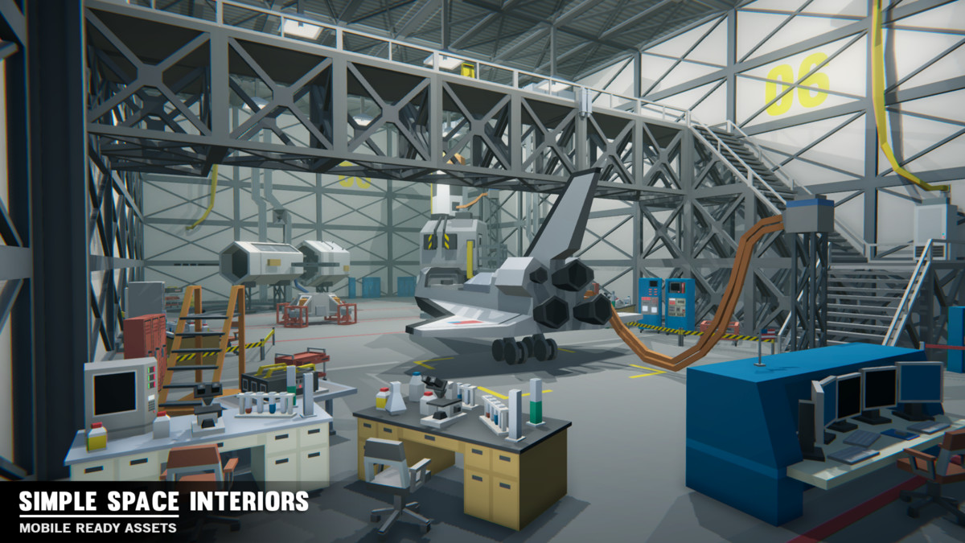

1. (100 marks) Create the main hangar/lab.

* This should *mimic* or *emulate* the overall shape of the room in the image on page 4, *not* what’s placed inside it (that’s in later questions). In other words, it should look reasonably “the same” but doesn’t have to be “identical”.
* It is 5 “blocks” (SM_Env_Construction_Wall model short axis) high. These models are 5x10 in size (5 units high and 10 units “long”).
* The floor is 8 x 12 “floor panels” (SM_Env_Floor_01 model) in size.  
  These floor panels are 5x5.
* Place six (6) of ceiling lights in the room, using your choice of the “Ceiling_Light” models.
  + Each one of these will be associated with a small white point light (like a light bulb) that lights up a little bit of the scene. (in other words, the room will be much darker than the image is – it looks like it’s been lit by a single directional light)
  + (BONUS: 10%) Make these lights downward facing white spot lights.
  + 5 of the lights should make a gentle penumbra on the floor, but one of the lights should have a hard edge to the spotlight.
  + Add one more *very* dim general light (either a directional light or a large, dim point light) so that the rest of the scene is *somewhat* visible.  
    i.e. The lights should look like the source of the lights, and you should see the “circle” of light on the floor, but there should be enough ambient light spill (from this light) to see everything else, just dimly.

1. (150 marks) Add the walkway to the centre of the scene:

* The walkway part is made up of a number of “Construction_Block” models. Choose the ones you feel are appropriate. Note that the walkway spans the entire width of the hangar, going into the wall on the left hand side of the image.
* The right side is made up of “construction blocks” as well as stair models. Note that there is a “landing” near the bottom.
* Place a door model where the walkway connects to the wall (on the left hand side). This would be for people to exit the hangar. Choose one of the “ControlRoom_Doorway” and matching “ControlRoom_Door” models for this doorway.
* Place two small red and green lights under the walkway:
  + Use the “SM_Env_Ceiling_Light_04” model, which is one red and one green light.
  + Add a small red and small green point light *just under* these lights. This will illuminate the lights and give a small glow to anything nearby, like these lights were illuminating.

1. (200 marks) Add a number of props to the scene:

* Add a SM_Prop_Desk_Lab_01 and SM_Prop_Desk_Lab_02 models to an appropriate location in the scene, somewhere away from the walls.
* Add one of the “bigger” (SM_Prop_Desk_01 and SM_Prop_Desk_03) and one of the “smaller” (SM_Prop_Desk_02 and SM_Prop_Desk_04) desks to the scene, somewhere away from the walls and at an angle.
* On the larger desk, place four (4) SM_Prop_Beaker_01 models.
* Appropriately place 10 more “small item” models of your choice.
  + A “small item” being beakers, monitors, microscopes, etc.
  + “Appropriate” means that they are deliberately placed in a “sensible” location. So lockers and server racks would go against the walls, phones on desk, chairs on the floor, etc.
* Make them an “appropriate” single colour. You can use the textures or the images from the website for guidance, but I don’t want them all the same colour grey, or some random crazy colours either. I’m looking to see that you deliberately picked a reasonable colour.   
    
  If they are “stupidly” or randomly placed, then you won’t get marks for this.
* Place the “Shuttle”, the “Satellite”, and the “Rocket” in a reasonable location in the scene  
  i.e. like they are in the image.

1. (200 marks): Make one of the walls “open” (like a garage bay door) to show the “space” outside.

Airplane hangar doors open horizontally, opening in the middle and sliding open.   
Here’s a few examples of this:

* + <https://c8.alamy.com/comp/2E7A1HC/toronto-aerospace-museum-volunteers-pull-open-giant-hangar-doors-to-unveil-a-life-size-model-of-the-avro-arrow-fighter-during-a-media-preview-in-toronto-september-28-2006-the-toronto-built-arrow-was-the-worlds-most-advanced-new-jet-fighter-design-when-the-canadian-government-killed-the-program-for-political-and-economic-reasons-in-1959-reutersjp-moczulski-canada-2E7A1HC.jpg>
  + <https://www.youtube.com/watch?v=8VxM_jE7sdg&ab_channel=JewersDoors>
  + <https://www.youtube.com/watch?v=wzr-zUcmtCM&ab_channel=SprungCorporate>

Choose one wall of the hangar as your “door”. I’d suggest the narrower wall farthest from the “tunnel” entrance (in the image on page 3, it would be the door “in front” of the space shuttle).

* + Place a bunch of small white spheres “far away” and “in front” of the hangar door. These are supposed to look like little stars when the doors are opened, so you *shouldn’t* see them until the doors open.
  + To “open” the doors, change their location a little bit over time. You can tie this to the “delta” or “frame” time, or just “hard code” a small number so gently open over time.
  + Note the doors “telescope” into each other. Graphically, you can mimic this by either:
    - Moving the different “panels” of the doors at a different speed (1st video), **OR**
    - **(BONUS 10)** Moving one panel at a time until it “hits” the next panel (2nd video)
  + When the doors are completely open, they need to stop.   
    When open, you should still see a little bit of them. In the 2nd video, around the 1:00 minute point, the doors are completely open, but have just collapsed into one panel.   
    In other words, they shouldn’t disappear off into space or something – they have to stop.
  + Assign a keyboard key to start opening the doors.
  + While the doors are opening, change the lighting of the red and green lights under the walkway (from question 2).
    - If you used point lights, then these would gradually “pulse”, cycling between brighter and smoothly dimmer, then back again. You do this by gradually changing the attenuation over time. This can be using a sin wave (using the sin function) or “linearly” ramping up the brightness, holding for a while, then ramping down, holding for a while, etc.
    - If you used spot lights, do the same thing with the brightness.
    - (BONUS: 10%) Make the lights rotate (something like this: <https://www.youtube.com/watch?v=HrEsTPPv1bk>) where the spot lights would cast a light on the walls while they slowly rotate around.   
      You don’t have to change the attenuation if you do this.
  + Add another key to close the doors (the rotating light should run at this time, too).

**That’s it.**